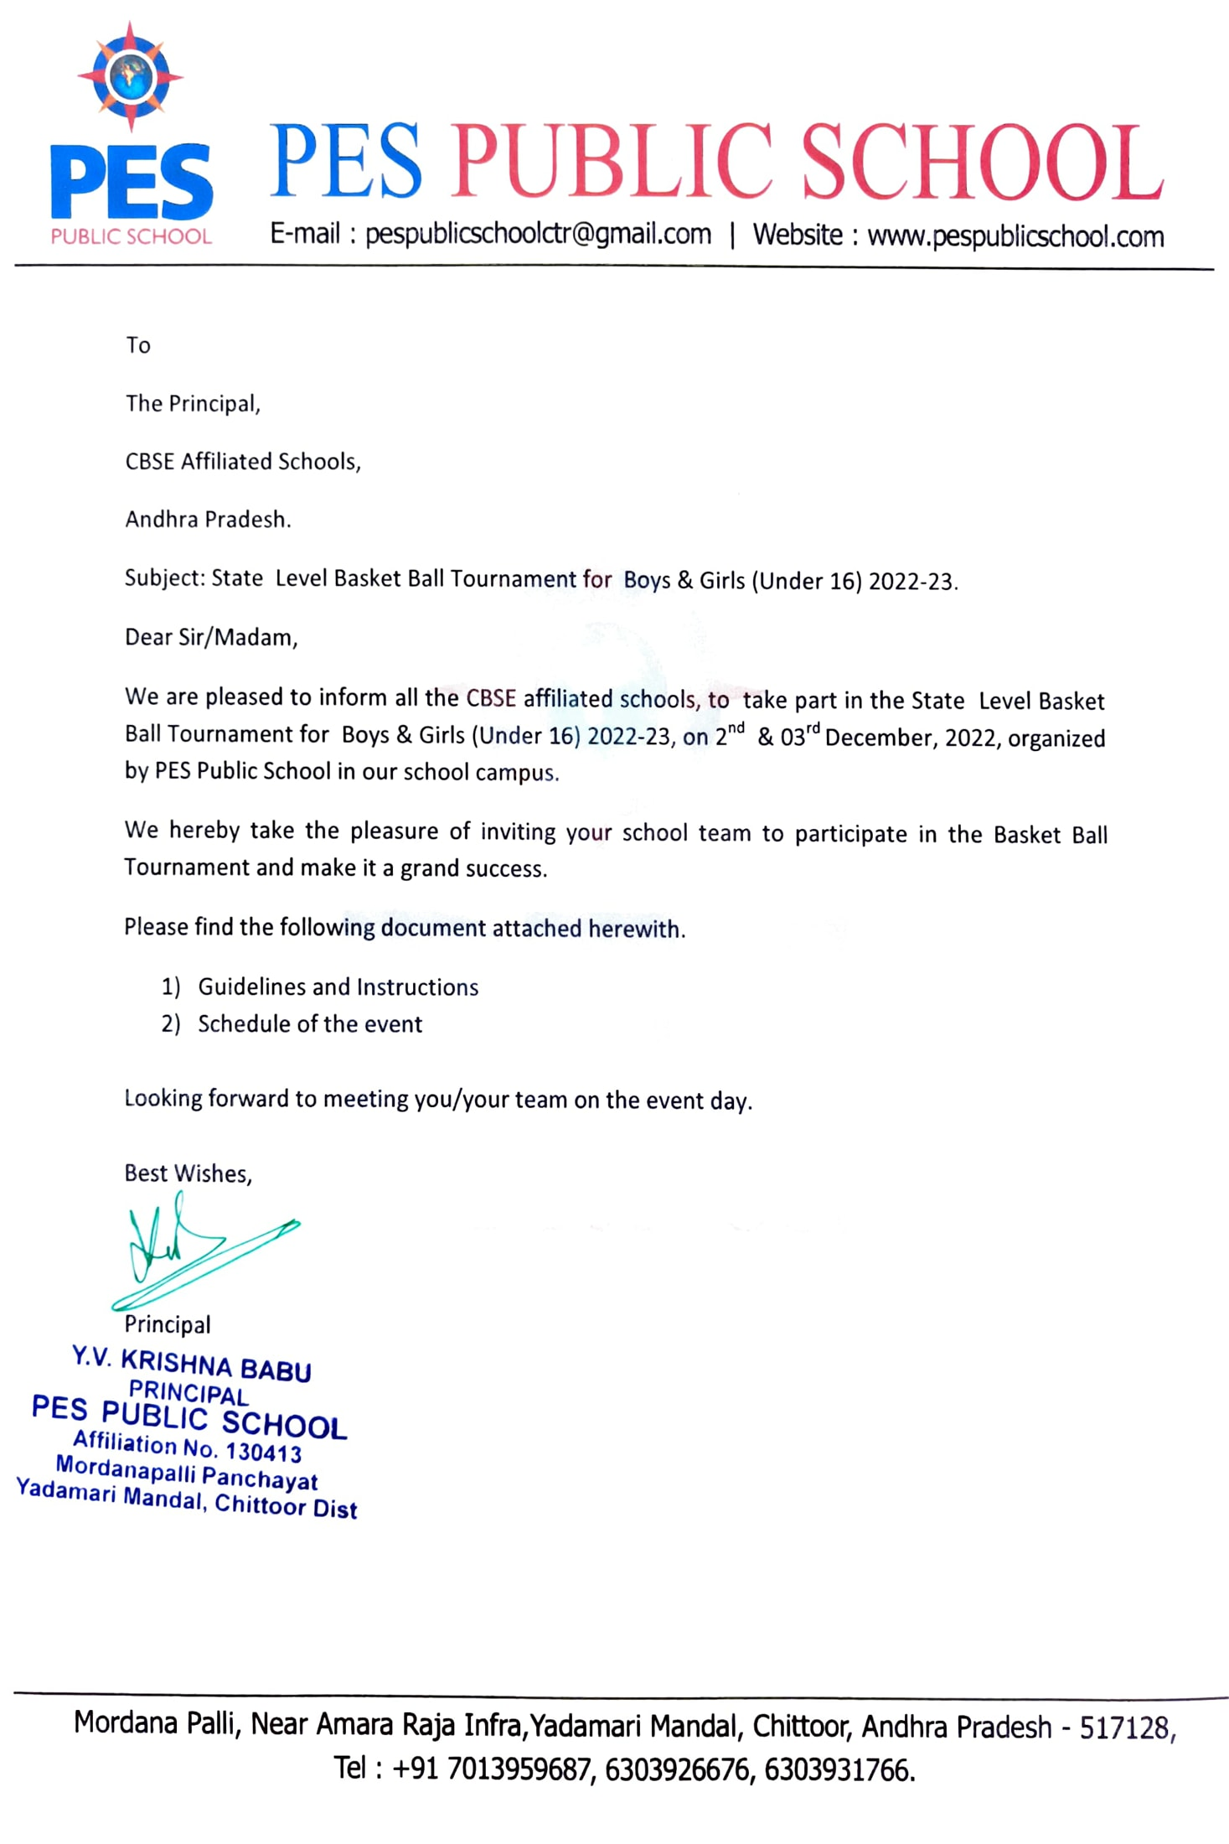

PES PUBLIC SCHOOL, CHITTOOR

STATE LEVEL BASKET BALL BOYS & GIRLS UNDER-16 TOURNAMENT-2022-23
SCHEDULE OF EVENTS

Name of the Principal Mr. Y V KRISHNA BABU (6303926676)

Organizing Secretary Mr.C Madan Mohan (6303931766)

Asst. Organising Secretaries Mr.Mahesh Babu, Mr.Rudraiah Naidu, Mr.Arjun, Ms.Sarala

Name of the event
State Level Basket Ball Tournament – 2022-23

Venue
Address
PES PUBLIC SCHOOL, CHITTOOR
NearAmarRaja Growth Corridor,
Palamner Road, NH-4,
Yadamari Mandal, Chittoor - 517128

E-mail ID pespublicschoolctr@gmail.com

Website www.pespublicschool.com

School Contact No. Date of the Tournament
7013959687

nd rd
02 & 03 December,2022

Reporting Date

Coaches and Managers meeting Opening Ceremony
Closing Ceremony
01st December, 2022 by 4:00pm

01st December, 2022 by 5:00pm
nd
02 December,2022 at 9:00 am
rd
03 December, 2022 at 3:00 pm

Boarding & Lodging
In school campus

Page 1 of 5

PES PUBLIC SCHOOL

STATE LEVEL BASKET BALL ( BOYS &GIRLS) - GUIDELINES AND INSTRUCTIONS TO TEAM
We welcome you to the State Level Basket Ball Tournament 2022-2023, being organized from 02nd December to 03rd December by PES Public School, Chitoor.
We at the organizing committee are committed to providing you with the most comfortable stay & congenial atmosphere and convey our Best wishes for your performance in the competition.

In order to make your stay comfortable and the competition successful, we would like you to kindly make note of the following guidelines related to the conduct of Basket Ball Tournament.

- Schools which are seeking accommodation facility on school campus are requested to send the details of the number of students and officials accompanying latest by 20th November 2022. If we do not receive the confirmation for accommodation by 20th Nov,2022, the participating school may have to make their own arrangement for accommodation.
- An outstation school which requires transport facility is requested to send their travel details latest by 20th November 2022 in the format attached.
- Accommodation and arrangement for food will be made available inside the school campus.
- The participating schools are required to pay an amount of Rs.500/-(Five Hundred only) (Cash only) as Registration Fee at the time of registration.
- A meeting of Coaches/ Managers of the schools will be held on 01st December 2022 at 5:00pm in our school premises to declare the draws of the matches and brief the rules and regulations of Basket Ball Tournament.
- The opening Ceremony will be held on Friday 02nd December. 2022 at 9:00 am. All the
participating teams are requested to report at the venue by 8:00 am.
- The matches will be conducted between 8:00 am and 6:00 pm. However, of deemed necessary, it may be extended beyond 6:00 pm.
- The principals of the local schools are requested to send their teams well in time as per the schedule and cooperate in smooth conduct of the matches to avoid the chances of walk over.
- Alcohol, Non-Veg food, smoking is strictly prohibited in the school premises.

ACCREDITED REPRESENTATIVES (TEACHER/COACH/MANAGER):

- All the teams shall be accompanied by a Teacher/Coach/Manager designated by the participating school principal (Lady Coach or teacher compulsory along with Girls Team)
- No team will be permitted to participate without accompanying official.
- No team shall be accompanied by more than two officials.
- The officials accompanying the team shall have a valid Identity Card issued by their school Principal.
- No extra person shall be permitted to stay inside the school premises and on the play field along with the teams.

Page 2 of 5

ELIGIBILITY:

- Only bonafide students shall be eligible to participate. Feeding any non bonafide student shall lead to disqualification of the team.(Bonafide certificate from school to be produced.)
- Incomplete information in any respect is liable for disqualification of team.
- Any violation in eligibility (over age or impersonation) shall be dealt according to rules.
- Any team not fulfilling the eligibility criteria before the commencement of the tournament shall not be permitted to Participate.
- At the time of registration teams should get
  - School Flag
  - Group photograph of the team attested by the Principal.
  - Bonafide Certificate
  - UID of participants attested by the Principal.
  - School ID Card
  - School covering letter signed by principal
  - Team List

DISQUALIFICATIONS: A player / team may be disqualified/ scratched for the following reasons.

- If the ineligibility of any member of the team is detected.
- Misbehaviour on ground by players or accompanying official.
- Use if abusive language by players or accompanying official.
- Misbehaviour with Officials/ Opponents by team member or accompanying official.
- Indiscipline at the place of stay by Team member or accompanying official.
- Damaging the school property.
- Indiscipline during the Opening and Closing ceremonies by Team members or accompanying official.

Page 3 of 5

BOARDING & LODGING

  - Accommodation and arrangement for food will be made available inside the school campus..
  - The team member may please be instructed to observe discipline, code of conduct and use the school property with utmost vigilance.
  - School will not be responsible for any kind of loss of valuables including gold, ornaments, mobile phones or money of the visiting teams.
  - If the school property is damaged by the participating team members, the damage cost will be collected from the respective schools.
  - The team is expected to carry bed spread/sheet, blanket, toiletries and other personal material as per their requirement.

TRANSPORTATION

  - The host school is making transport arrangements for the outstation teams to pick up from Chittoor Railway Station or Bus Stand.
  - You are requested to send us your Travel Plan in the format attached.

For further information and any clarification please contact,
Mr.Rudriah Naidu ( Asstt. Organizing Secretary) Ph.9573803471.

Page 4 of 5

STATE LEVEL BASKET BALL BOYS & GIRLS TOURNAMENT 2022-23

TRAVEL DETAILS PROFORMA
NAME OF THE SCHOOL:


- NAME OF THE COACH:

PHOTOGRAPH DULY ATTESTED BY THE PRINCIPAL


- NAME OF THE MANAGER:

PHOTOGRAPH DULY ATTESTED BY THE PRINCIPAL

- TRAVEL DETAILS:

Arrival: Bus/ Train Name
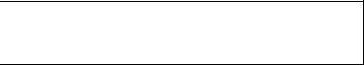
Date:
Time:

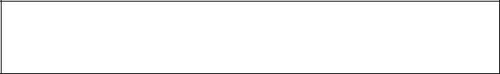
No.of students:

Arrival Point:

Departure: Bus / Train Name

Date: Time:

Departure Point:

Contact Person’s Name and Mobile Number:
No. of Students:

School seal Principal’s Signature and seal

Page 5 of 5

LOCATION MAP

